MY PET
Poslušaj posnetek (lahko tudi večkrat). Razporedi ljubljenčke v pravilen vrstni red (Number:…, po vrsti tako, kot jih slišiš na posnetku). Pobarvaj ljubljenčke. Dopolni povedi (1. What pet is it? 2. What colour is it? 3. What's its name?).
Number: 1  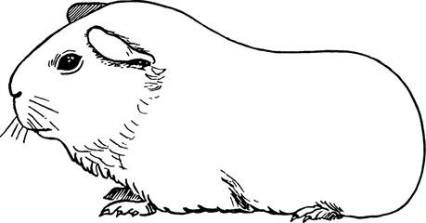  1. I've got a guinea pig.  2. It's brown and white.  3. Its name is Poli. | Number: 2  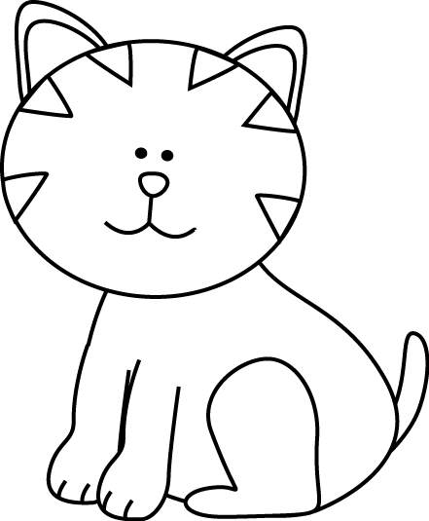  1. I've got a __cat_________.  2. It's __yellow and orange_.  3. Its name is ____Lilly___. | Number: 6  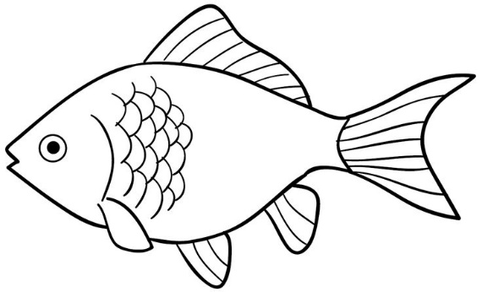  1. I've got a _goldfish__.  2. It's gold, yellow and orange__.  3. Its name is _Zlatko__.
Number: 5  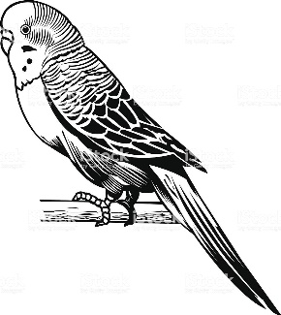  1. I've got a __parrot___.  2. It's _green and blue_.  3. Its name is ___Piki___. | Number: 3  1. I've got a _snake___.  2. It's __green__.  3. Its name is ___Mimmy__. | Number: 4  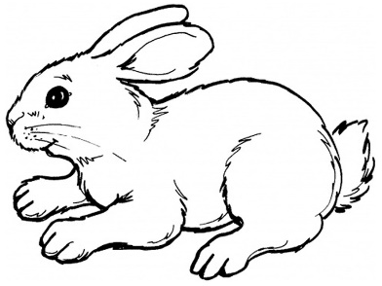  1. I've got a __rabbit___.  2. It's __brown____.  3. Its name is _Moony____.

